Name:Nana Akua Konadu Agyeman-Gyebi

Index Number: 8281619

Program: Telecommunication Engineering

Lecturer: Bismark Donkor

Date: February 24,2020

**Half-Wave Rectification**

Rectification is the process of converting alternating voltages to direct voltages.

A rectifier is a device that converts alternating current (AC) to direct current (DC)

A half wave rectifier is defined as a type of rectifier that only allows one half-cycle of an AC voltage waveform to pass, blocking the other half-cycle.

**Components Used**

1. One diode
2. Transformer
3. Copper wires
4. Resistor

The diagram below illustrates the basic principle of a half-wave rectifier. When a standard AC waveform is passed through a half-wave rectifier, only half of the AC waveform remains. Half-wave rectifiers only allow one half-cycle (positive or negative half-cycle) of the AC voltage through and will block the other half-cycle on the DC side, as seen below.

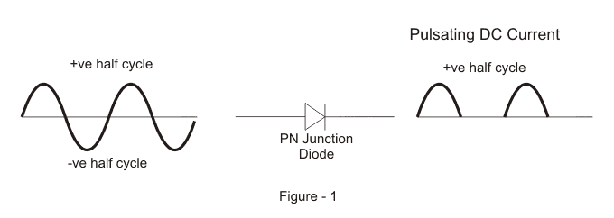

**Procedure**

The components are connected together as shown in the diagram below.

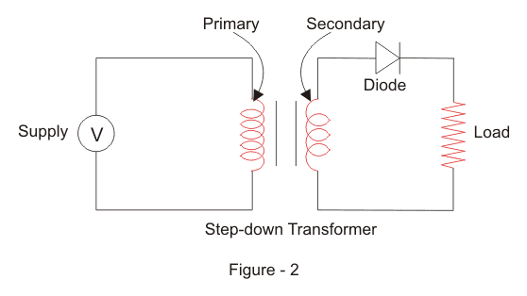

First, a high AC voltage is applied to the to the primary winding of the [step-down transformer](https://www.electrical4u.com/step-down-transformers/) and we will get a low voltage at the secondary winding which will be applied to the diode. During the positive half cycle of the AC voltage, the diode will be forward biased and the current flows through the diode. During the negative half cycle of the AC voltage, the diode will be reverse biased and the flow of current will be blocked.

The output waveform of Half-Wave Rectification is as shown below;

**Full-Wave Rectification**

A Full Wave Rectifier is a circuit, which converts an ac voltage into a pulsating dc voltage using both half cycles of the applied ac voltage. It uses two diodes of which one conducts during one half cycle while the other conducts during the other half cycle of the applied ac voltage.

**Components Used;**

1. Two diodes
2. Conducting wire
3. Step down transformer
4. Resistor

**Procedure**

The components are connected in the diagram as shown below:

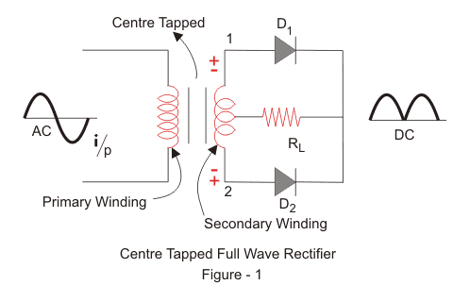

**The circuit diagram is as follows**  
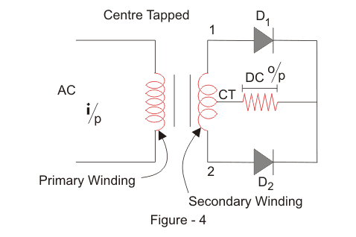

**Working of Centre-tapped Full Wave Rectifier**

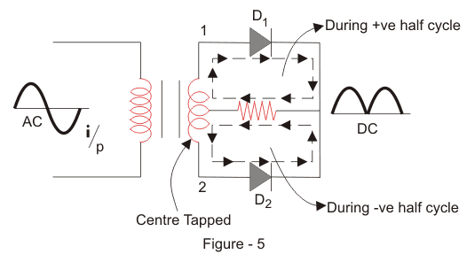  
We apply an AC voltage to the input [transformer](https://www.electrical4u.com/what-is-transformer-definition-working-principle-of-transformer/). During the positive half-cycle of the AC voltage, terminal 1 will be positive, centre-tap will be at zero potential and terminal 2 will be negative potential. This will lead to forward bias in diode D1 and cause [current](https://www.electrical4u.com/electric-current-and-theory-of-electricity/) to flow through it. During this time, [diode](https://www.electrical4u.com/diode-working-principle-and-types-of-diode/) D2 is in reverse bias and will block current through it.  
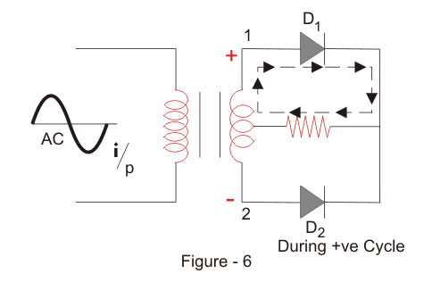  
During the negative half-cycle of the input AC voltage, terminal 2 will become positive with relative to terminal 2 and centre-tap. This will lead to forward bias in diode D2 and cause current to flow through it. During this time, diode D1 is in reverse bias and will block current through.  
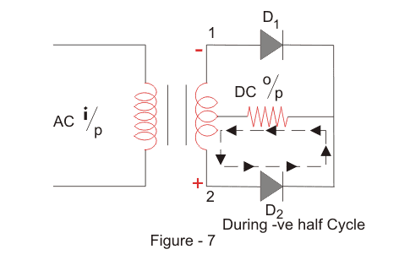  
During the positive cycle, diode D1 conducts and during negative cycle diode D2 conducts and during positive cycle. As a result, both half-cycles are allowed to pass through. The average output DC voltage here is almost twice of the DC output [voltage](https://www.electrical4u.com/voltage-or-electric-potential-difference/) of a [half-wave rectifier](https://www.electrical4u.com/half-wave-rectifiers/).